Lab Walkthrough- 4.7.2

Packet Tracer – Connect the Physical Layer

Objectives
The objectives of this lab were to: -
- Identify the physical characteristics of internetworking devices.
- Examine the management, LAN, and WAN interfaces of a Cisco router.
- Select and install appropriate expansion modules for connectivity.
- Connect devices using the correct cable types.
- Verify network connectivity between wired and wireless devices.

Part 1: Identify Physical Characteristics

Step 1: Identify Management Ports of a Cisco router.
The Cisco 1941 East router was examined in the Physical tab.
Observed Management Ports:
- Console Port (RJ-45)
- AUX Port
The console port is used for local configuration through a console cable, while the AUX port supports remote access via modem.
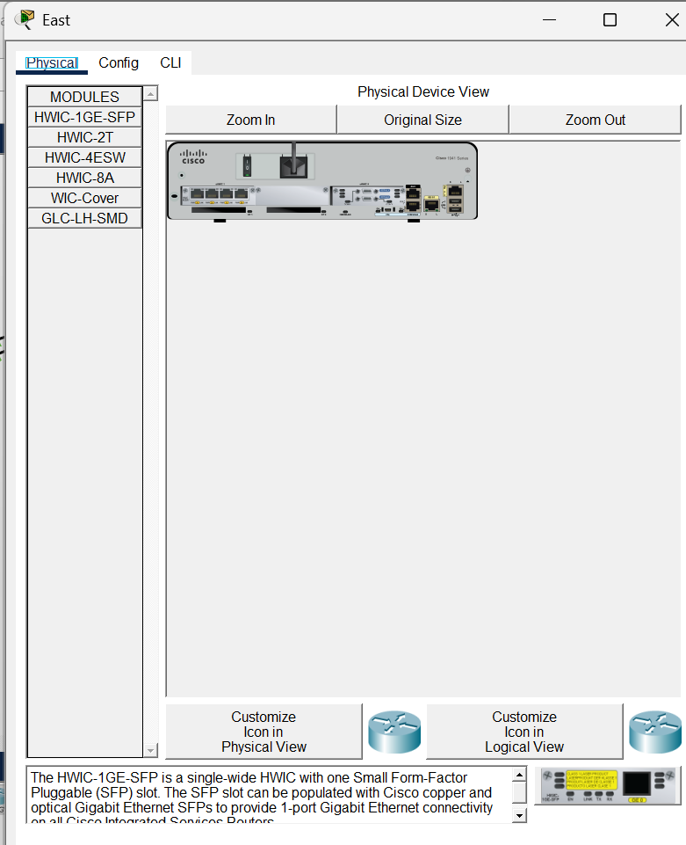

Step 2: Identify LAN and WAN Interfaces
Using the CLI command: show ip interface brief
The following interfaces were identified:
LAN Interfaces:
- GigabitEthernet0/0
- GigabitEthernet0/1
WAN Interface:
- Serial0/0/0
The VLAN1 interface was also listed, but it is a virtual interface that exists only in software.
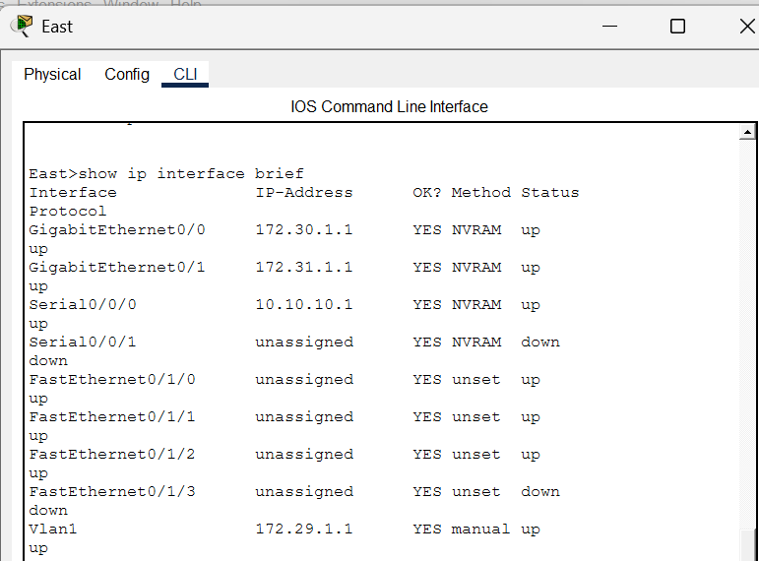

Step 3: Check Default Bandwidth
Commands used:
show interface gigabitethernet 0/0
show interface serial 0/0/0

Observed Default Bandwidth:
- GigabitEthernet → 1,000,000 Kbit (1 Gbps)
- Serial Interface → 1544 Kbit (1.544 Mbps)
The serial bandwidth value is used by routing protocols and does not represent actual physical speed.
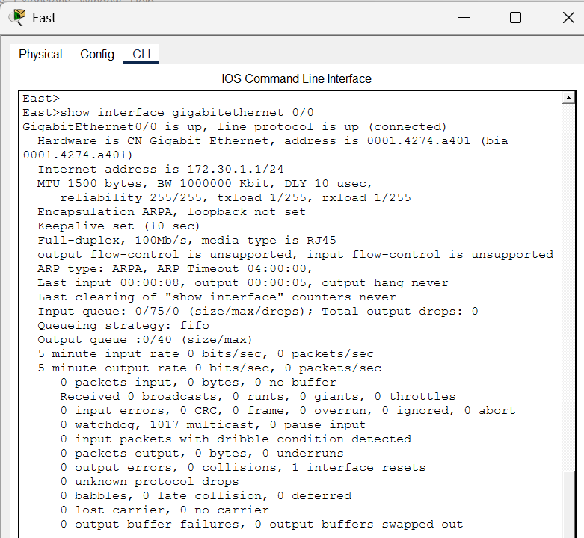
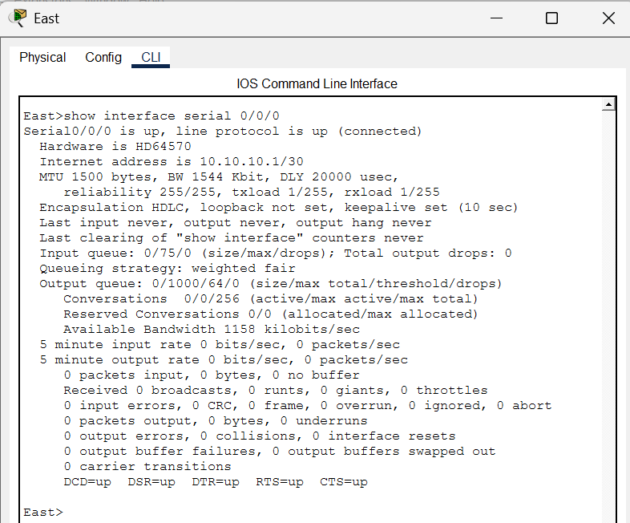

Step 4: Identify Expansion Slots
The Cisco 1941 router contains:
- Two HWIC expansion slots for additional modules.
The 2960 switch does not support modular expansion.

Part 2: Select the correct modules for connectivity
To connect PCs directly to the router without purchasing a new switch, the following module was selected:
Module Installed on East Router:
- HWIC-4ESW (4-Port Ethernet Switch Module)
This module provides four additional FastEthernet ports, allowing up to four hosts to connect directly to the router.
For fiber connectivity between switches:
Module Installed on Switch2:
- Gigabit SFP Fiber Module
Devices were powered off before inserting modules and powered on after installation.
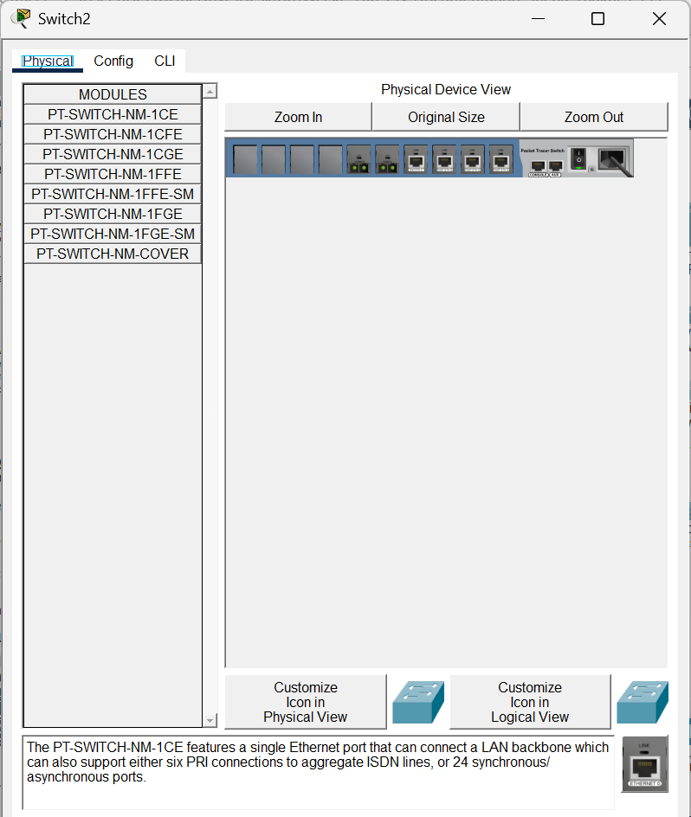

Part 3: Connect Devices
Devices were connected according to the provided connection table using the correct cable types.
Cable Types Used:
- Copper Straight-Through:
  - PC ↔ Switch
  - Router ↔ Switch
  - Router ↔ PC (via HWIC module)
- Copper Cross-Over:
  - Switch ↔ Switch (Switch4 to Switch3)
- Fiber:
  - Switch3 ↔ Switch2
- Serial DCE:
  - East ↔ West (Serial0/0/0)
After completing all connections, the Packet Tracer score increased, confirming correct cabling.
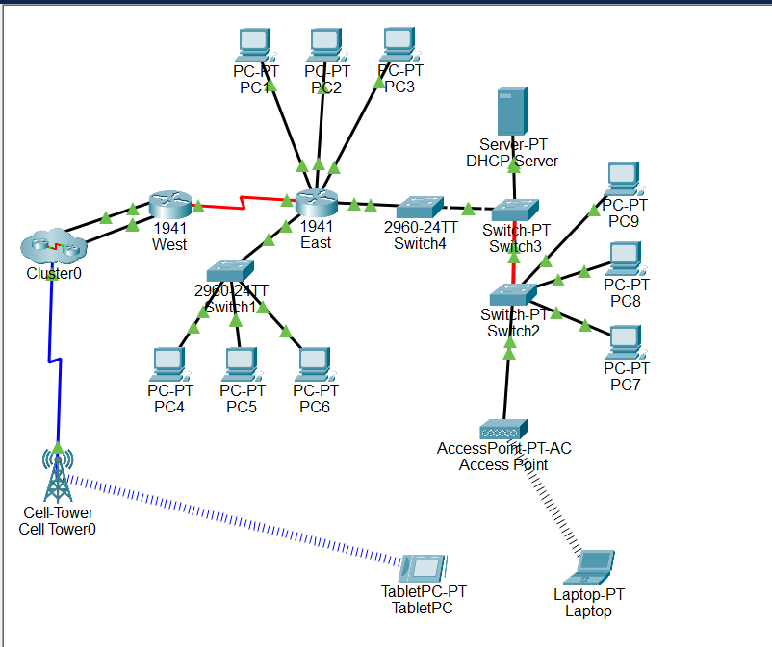

Part 4: Check Connectivity
Step 1: Verify Interface Status
Command used: show ip interface brief
All required interfaces displayed:
Status: up
Protocol: up
This confirmed correct physical and logical connectivity.

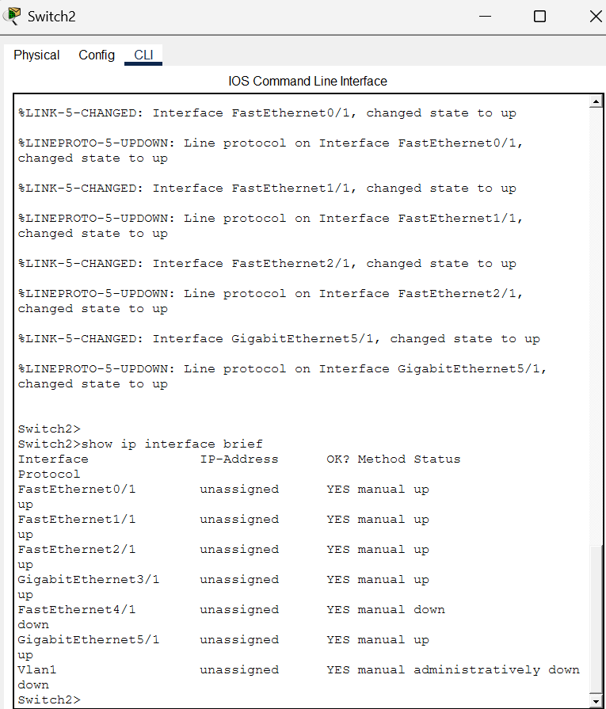
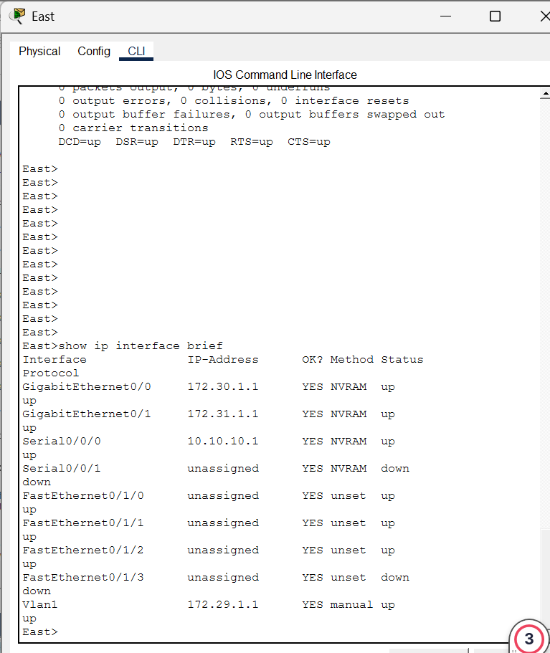

Step 2: Test PC Connectivity
Initially, PC1 showed:
IP Address: 0.0.0.0
This indicated that DHCP was not assigned.
After enabling DHCP on the PC, it received a valid IP address.
Ping test: ping 172.29.1.1
Result:
Reply from 172.29.1.1
Packets: Sent = 4, Received = 4, Lost = 0
Connectivity was successful.
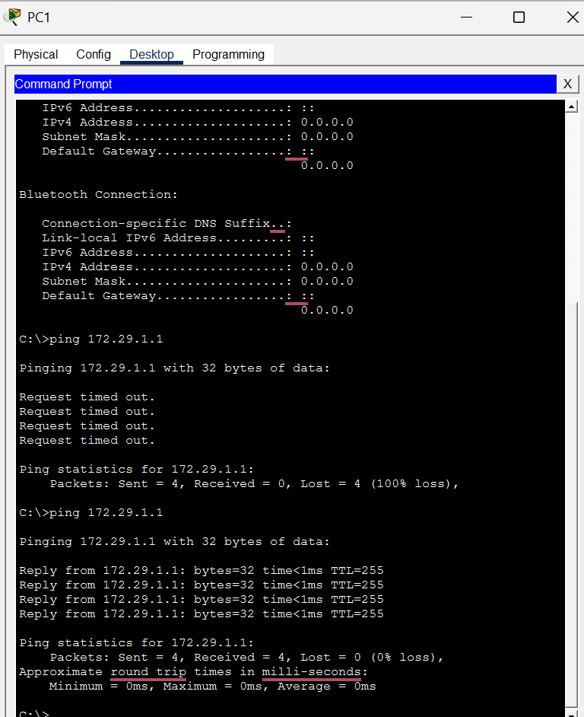
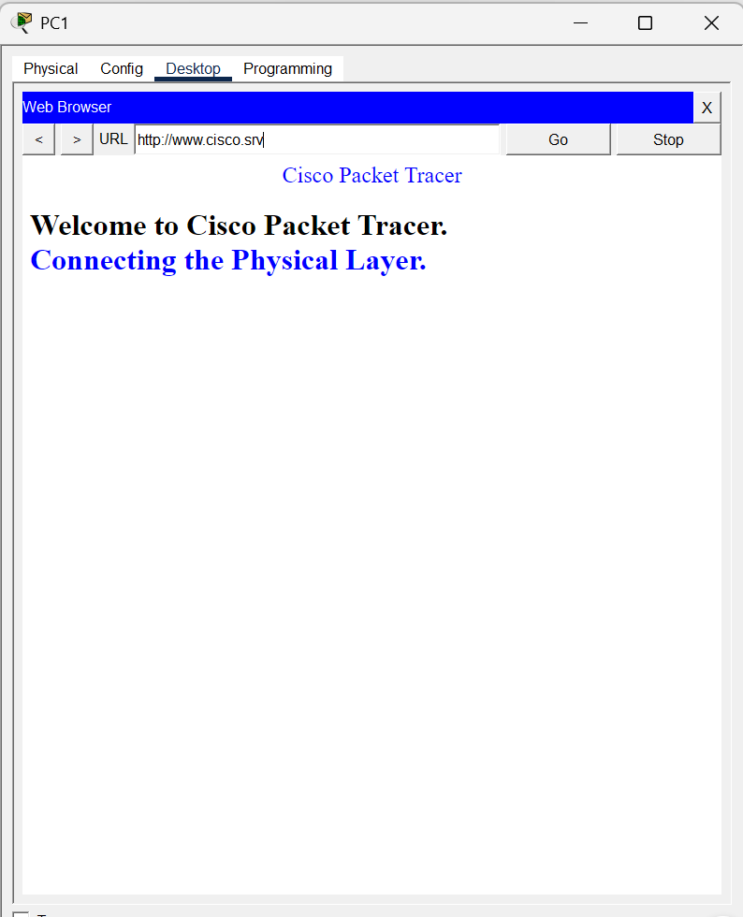

Step 3: Wireless Testing
Laptop:
- Wireless0 interface enabled
- Successfully accessed www.cisco.srv
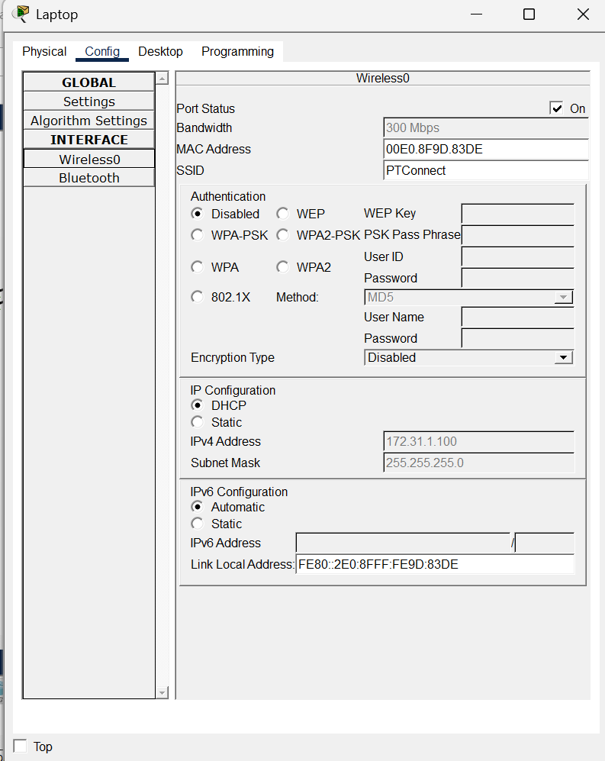
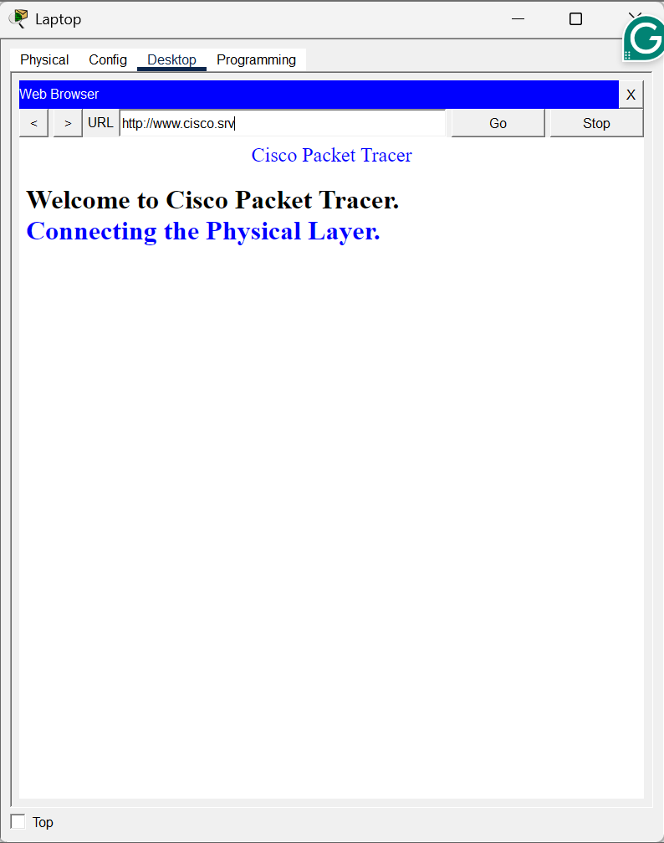
Tablet:
- Wireless0 tested successfully
- WIFI disabled
- 3G/4G Cell1 enabled
- Successfully accessed web page via cellular connection
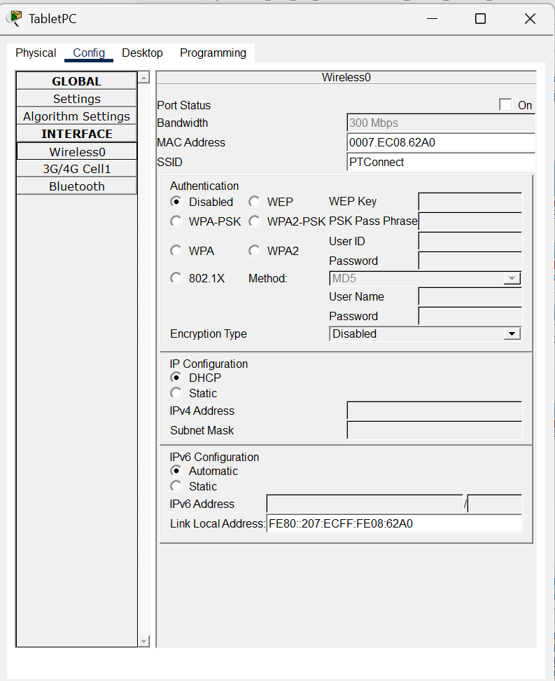
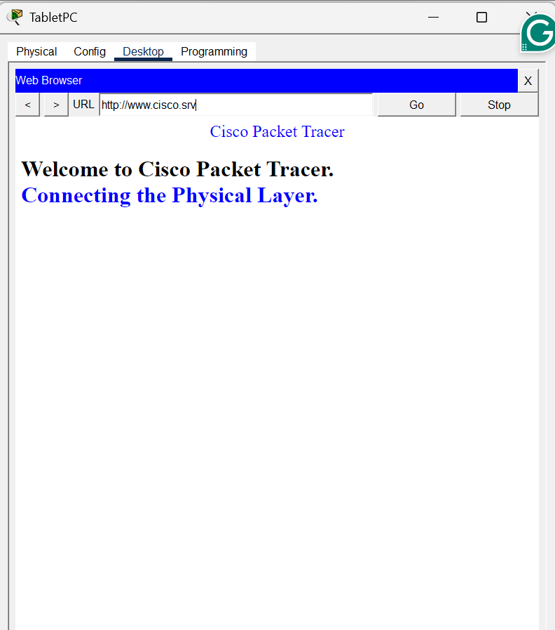

Step 4: Final Connectivity Verification
All PCs were able to:
- Ping their default gateway
- Access the web server
- Communicate across networks
This confirmed full network functionality.


Conclusion
This lab successfully demonstrated:
- Identification of router physical components
- Installation of correct expansion modules
- Proper cable selection and physical connections
- Interface verification using CLI commands
- DHCP troubleshooting and IP assignment
- Wired and wireless connectivity testing
All required tasks were completed successfully, and full connectivity was achieved across the network.

